

In [1]: import numpy as np

import matplotlib.pyplot as plt

def drawGraph(title, objectsF, objectsC):

- Create data colorF = "green" colorC = "blue" groupF = "Fragment" groupC = "Controller"

xF = np.arange(len(objectsF))

yF = objectsF

xC = np.arange(len(objectsC))

yC = objectsC

# Plot

fig = plt.figure()

sub_plt = fig.add_subplot(1, 1, 1)

sub_plt.scatter(xF, yF, alpha=0.5, c=colorF, edgecolors='none', s=30, label=groupF)

sub_plt.scatter(xC, yC, alpha=0.5, c=colorC, edgecolors='none', s=30, label=groupC)

plt.ylabel('ms')

plt.title(title)

#add trend lines

zF = np.polyfit(xF, yF, 0)

pF = np.poly1d(zF)

plt.plot(xF,pF(xF),"g--")

zC = np.polyfit(xC, yC, 0)

pC = np.poly1d(zC)

plt.plot(xC,pC(xC),"b--")

plt.plot(0,0,"r--")

#add description subtitle for two type of data

plt.legend(loc='upper center', ncol=2, bbox_to_anchor=(0.5, -0.05))

#increace figures size

F = plt.gcf()

Size = F.get_size_inches()

F.set_size_inches(Size[0]*2, Size[1]*2, forward=True)

plt.show()



In [2]: drawGraph( 'Schedule->Details : UiAutomator : for',

(521, 574, 510, 526, 525, 571, 534, 550, 569, 580, 531, 522, 527, 525

- 572, 523, 534, 525, 572, 559, 533, 563, 522, 522, 524, 520, 523, 524, 5

21, 575, 522, 531, 522, 525, 530, 528, 538, 524, 557, 518, 527, 581, 583, 514, 579, 523, 526, 581, 533, 531, 580, 539, 565, 573, 527, 523, 565, 535
- 555, 524, 530, 538, 576, 558, 571, 573, 577, 555, 578, 563, 527, 573, 5

77, 522, 568, 535, 530, 584, 591, 575, 587, 540, 568, 585, 570, 525, 542, 582, 569, 538, 529, 523, 574, 527, 564, 600, 583, 581, 603, 603),
(275, 265, 247, 235, 258, 247, 258, 256, 237, 261, 242, 272, 250, 238

- 256, 245, 274, 237, 240, 252, 276, 251, 237, 261, 273, 255, 244, 271, 2

41, 244, 277, 268, 250, 271, 253, 255, 297, 259, 251, 282, 255, 258, 290, 271, 261, 301, 273, 270, 282, 275, 263, 297, 277, 258, 299, 267, 261, 314
- 276, 252, 294, 279, 269, 302, 261, 204, 301, 267, 201, 299, 271, 221, 3

02, 270, 209, 307, 272, 229, 302, 282, 254, 284, 291, 248, 297, 287, 266, 293, 285, 244, 281, 270, 247, 282, 221, 314, 271, 240, 286, 249, 295)
)
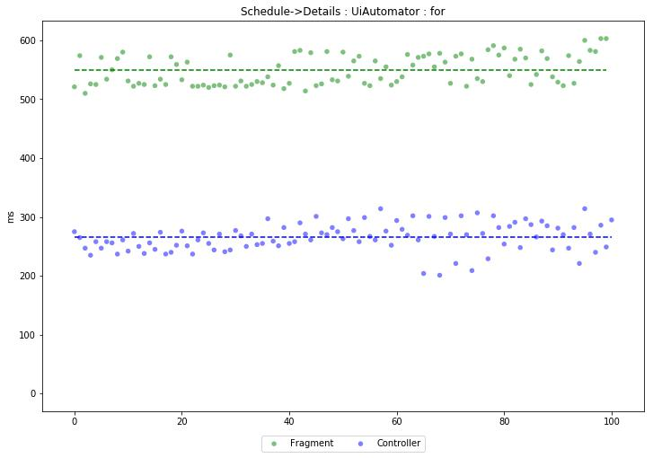



In [3]: drawGraph( 'Feed->Info : UiAutomator : for',

(567, 469, 508, 493, 458, 527, 488, 501, 509, 485, 476, 593, 494, 508

- 464, 597, 495, 473, 486, 476, 512, 473, 474, 482, 472, 509, 467, 537, 5

27, 464, 487, 486, 486, 520, 496, 481, 512, 498, 472, 497, 477, 485, 528, 488, 539, 500, 482, 487, 519, 460, 473, 535, 507, 515, 487, 523, 509, 478
- 529, 485, 488, 505, 494, 534, 491, 506, 514, 494, 488, 470, 540, 477, 5

39, 486, 489, 427, 510, 528, 543, 386, 522, 512, 510, 533, 527, 590, 494, 520, 499, 489, 530, 496, 672, 550, 500, 569, 542, 477, 479, 394, 522),
(529, 397, 416, 413, 405, 370, 440, 398, 382, 454, 389, 433, 357, 384

- 455, 437, 392, 392, 419, 451, 397, 289, 475, 380, 320, 395, 413, 395, 4

21, 389, 404, 396, 411, 438, 396, 407, 458, 402, 433, 393, 413, 412, 414, 393, 417, 421, 411, 394, 429, 399, 410, 437, 424, 402, 401, 408, 432, 397
- 403, 391, 418, 436, 416, 416, 433, 409, 468, 407, 419, 434, 399, 420, 3

23, 388, 399, 423, 394, 406, 427, 437, 412, 409, 440, 403, 405, 442, 422, 431, 409, 425, 432, 402, 448, 409, 418, 426, 440, 430, 440, 422, 452)
)
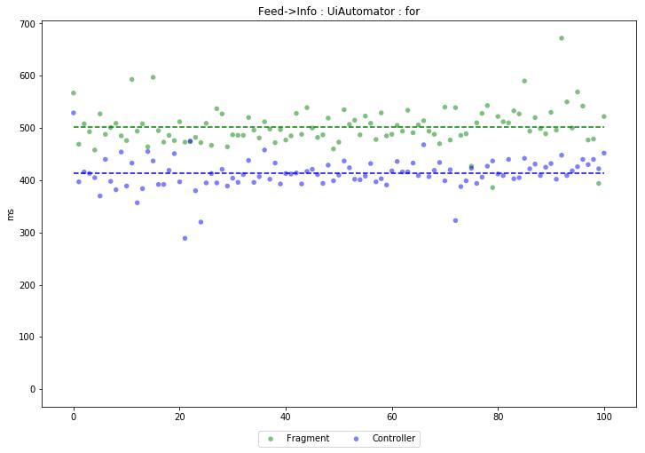

In [4]: drawGraph( 'Feed->Schedule : UiAutomator : for',

(132, 160, 152, 149, 130, 154, 142, 134, 140, 143, 133, 227, 144, 160

- 198, 150, 158, 133, 142, 158, 145, 155, 152, 164, 155, 169, 129, 141, 1

47, 154, 135, 154, 148, 236, 165, 158, 159, 173, 159, 145, 174, 172, 146, 198, 160, 155, 156, 247, 186, 225, 257, 164, 276, 167, 175, 178, 166, 159
- 140, 142, 179, 170, 150, 234, 171, 179, 261, 286, 223, 169, 216, 242, 2

47, 148, 150, 173, 157, 183, 177, 185, 177, 167, 250, 173, 153, 170, 152, 250, 263, 152, 175, 167, 168, 190, 163, 182, 176, 251, 161, 267),
(273, 269, 391, 253, 232, 247, 238, 265, 240, 265, 235, 246, 255, 237

- 290, 256, 235, 254, 241, 266, 244, 260, 239, 274, 250, 245, 254, 263, 2

65, 243, 291, 249, 251, 261, 244, 261, 246, 278, 260, 256, 255, 254, 256, 257, 267, 262, 276, 250, 255, 250, 268, 263, 247, 256, 254, 273, 244, 252
- 259, 258, 263, 259, 284, 258, 287, 249, 287, 251, 280, 300, 295, 251, 2

61, 268, 275, 250, 255, 271, 280, 266, 291, 260, 302, 265, 260, 269, 273, 276, 254, 272, 301, 242, 276, 263, 277, 274, 280, 272, 279, 263, 270)
)
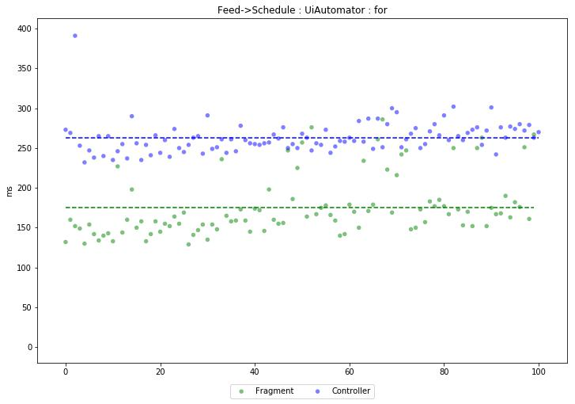



In [5]: drawGraph( 'Activity->Feed : UiAutomator : repeat',

(144, 59, 61, 80, 53, 56, 54, 62, 53, 56, 59, 52, 53, 52, 53, 52, 60, 61, 75, 54, 57, 83, 52, 66, 53, 53, 52, 52, 60, 66, 52, 52, 53, 55, 58, 5 3, 59, 52, 57, 53, 53, 53, 62, 54, 53, 52, 52, 56, 56, 53, 78, 53, 63, 81 , 52, 57, 55, 56, 77, 52, 69, 65, 52, 53, 53, 53, 54, 53, 64, 52, 55, 52, 53, 63, 80, 52, 61, 56, 53, 54, 52, 61, 54, 54, 52, 53, 53, 53, 53, 53, 5 3, 61, 54, 62, 53, 53, 53, 57, 53, 53, 56),

(190, 68, 67, 68, 79, 82, 74, 67, 74, 75, 76, 69, 67, 75, 67, 73, 65, 72, 75, 66, 79, 75, 67, 78, 65, 72, 67, 73, 75, 78, 74, 79, 66, 66, 71, 7 8, 74, 71, 66, 67, 66, 67, 69, 72, 67, 66, 68, 70, 79, 78, 74, 82, 75, 65 , 67, 74, 74, 97, 79, 76, 70, 66, 68, 68, 70, 68, 73, 71, 67, 74, 83, 77, 66, 81, 78, 74, 83, 69, 73, 74, 68, 66, 70, 75, 74, 75, 78, 76, 78, 67, 6 6, 71, 68, 82, 74, 73, 83, 77, 66, 68, 79) )
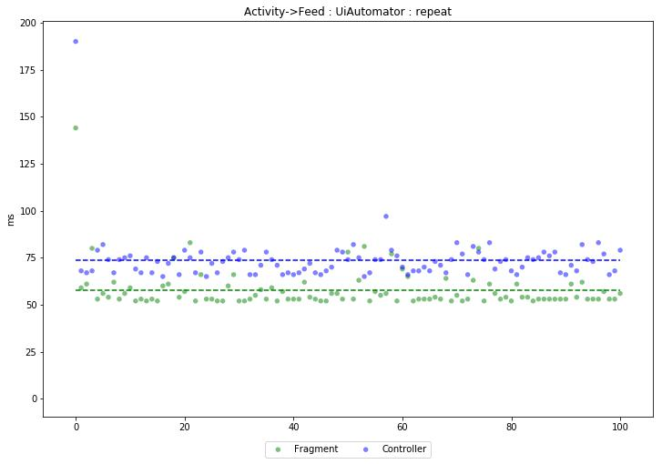



In [6]: drawGraph( 'Schedule->Details : Espresso : for',

(519, 520, 562, 513, 569, 553, 513, 505, 508, 508, 506, 553, 607, 508

- 515, 519, 519, 520, 520, 507, 562, 518, 516, 517, 517, 516, 522, 518, 5

06, 520, 559, 516, 552, 508, 523, 517, 507, 517, 520, 519, 553, 521, 510, 561, 509, 514, 514, 523, 510, 522, 517, 512, 512, 518, 515, 518, 509, 517
- 524, 522, 514, 523, 523, 523, 524, 524, 512, 523, 524, 523, 523, 533, 5

20, 515, 513, 560, 511, 519, 518, 525, 510, 525, 523, 528, 512, 522, 519, 521, 525, 525, 564, 522, 521, 526, 521, 525, 520, 525, 517, 524, 520, 568 ),

(251, 221, 230, 215, 189, 203, 206, 219, 220, 220, 219, 216, 207, 219

- 201, 213, 205, 202, 215, 217, 208, 216, 220, 201, 197, 247, 210, 193, 2

06, 221, 207, 235, 220, 205, 235, 208, 196, 239, 207, 223, 232, 230, 209, 242, 218, 236, 214, 210, 213, 253, 221, 241, 231, 207, 228, 221, 211, 257
- 216, 223, 228, 225, 221, 205, 225, 227, 231, 221, 204, 239, 216, 230, 2

31, 210, 260, 215, 252, 220, 224, 222, 232, 235, 244, 235, 242, 246, 232, 254, 211, 253, 225, 261, 230, 250, 225, 266, 231, 252, 227, 249, 219)
)
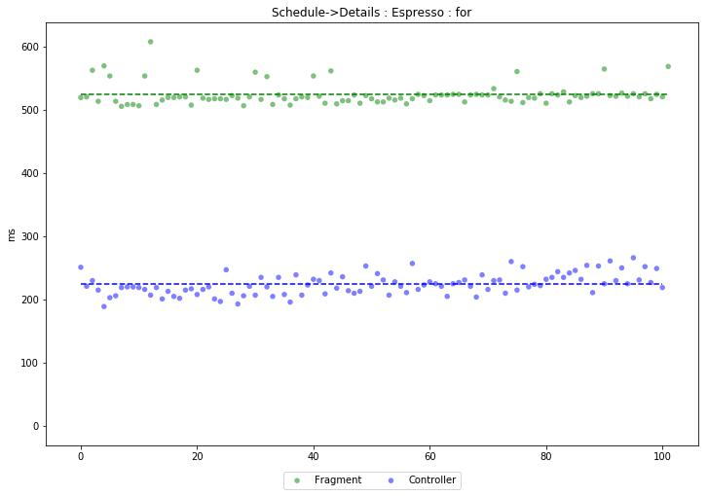

In [7]: drawGraph( 'Feed->Info : Espresso : for',

(470, 398, 364, 493, 382, 343, 406, 388, 422, 489, 375, 393, 417, 388

- 381, 511, 382, 391, 473, 449, 477, 393, 347, 505, 336, 478, 402, 497, 3

37, 382, 345, 410, 411, 521, 346, 392, 530, 521, 350, 481, 375, 408, 507, 514, 372, 556, 352, 430, 414, 400, 532, 531, 366, 376, 441, 414, 435, 491
- 539, 365, 497, 546, 502, 459, 428, 536, 529, 493, 456, 524, 517, 550, 4

03, 436, 419, 508, 415, 442, 416, 576, 415, 463, 515, 492, 514, 368, 513, 438, 509, 449, 527, 451, 518, 553, 538, 437, 526, 454, 521, 455, 368),
(458, 328, 370, 429, 394, 323, 485, 337, 513, 330, 373, 330, 344, 330

- 396, 461, 327, 463, 448, 379, 334, 388, 368, 389, 338, 488, 355, 337, 4

71, 348, 343, 372, 343, 386, 436, 393, 371, 344, 487, 363, 357, 459, 372, 333, 499, 340, 363, 355, 366, 358, 361, 335, 390, 445, 365, 356, 477, 455
- 504, 408, 355, 370, 350, 449, 364, 375, 355, 379, 440, 357, 366, 371, 4

56, 374, 356, 405, 492, 367, 359, 372, 352, 381, 460, 485, 472, 488, 359, 468, 461, 478, 357, 368, 360, 587, 449, 374, 477, 440, 499, 379, 445)
)
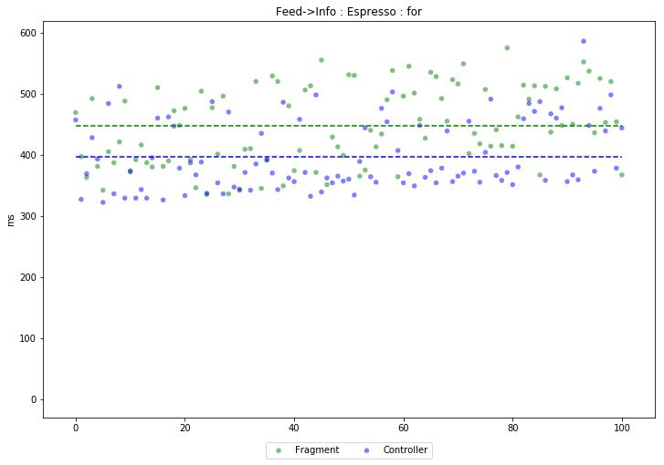

In [8]: drawGraph( 'Feed->Schedule : Espresso : for',

(226, 221, 195, 280, 258, 343, 210, 294, 159, 214, 216, 214, 215, 212

- 214, 299, 223, 234, 138, 161, 160, 170, 170, 228, 209, 153, 204, 228, 2

21, 213, 174, 215, 276, 295, 223, 222, 253, 289, 209, 163, 210, 263, 174, 208, 173, 227, 226, 295, 160, 224, 289, 294, 230, 156, 310, 178, 303, 163
- 297, 220, 230, 232, 288, 310, 294, 286, 301, 217, 284, 225, 300, 228, 2

13, 307, 225, 229, 152, 229, 184, 305, 227, 176, 301, 223, 317, 230, 160, 309, 209, 178, 310, 216, 181, 228, 229, 222, 233, 228, 244, 298, 181),
(250, 252, 191, 293, 212, 201, 205, 205, 228, 199, 320, 209, 213, 205

- 204, 207, 204, 201, 215, 220, 220, 213, 214, 206, 217, 203, 205, 291, 2

42, 218, 203, 313, 210, 210, 282, 203, 220, 230, 216, 216, 294, 223, 311, 216, 211, 288, 288, 307, 277, 218, 223, 286, 310, 288, 208, 289, 284, 282
- 274, 341, 218, 218, 197, 225, 280, 237, 220, 245, 289, 296, 196, 294, 3

39, 287, 281, 224, 297, 223, 220, 277, 300, 221, 220, 223, 299, 232, 298, 279, 290, 231, 223, 230, 219, 234, 223, 317, 221, 322, 226, 221, 284, 315
)

)
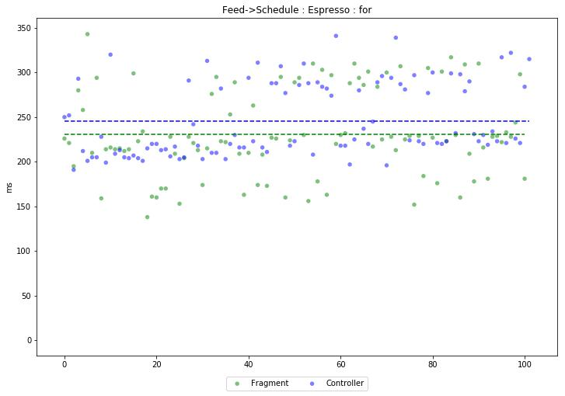



In [9]: drawGraph( 'Activity->Feed : Espresso : repeat',

(174, 46, 53, 50, 48, 56, 52, 44, 48, 46, 47, 45, 53, 45, 47, 53, 44, 55, 45, 44, 42, 61, 46, 57, 53, 59, 52, 54, 50, 54, 47, 56, 52, 45, 49, 5 4, 44, 46, 46, 51, 52, 45, 55, 48, 48, 44, 60, 53, 52, 48, 44, 46, 47, 54 , 47, 70, 44, 43, 51, 60, 46, 44, 50, 57, 44, 44, 44, 56, 50, 54, 44, 44, 47, 54, 44, 43, 52, 47, 54, 49, 50, 48, 45, 46, 44, 46, 46, 45, 52, 45, 4 9, 52, 44, 47, 52, 53, 45, 48, 55, 50, 44),

(262, 61, 69, 61, 58, 60, 68, 58, 62, 64, 61, 65, 69, 58, 59, 53, 55, 68, 62, 64, 58, 58, 58, 69, 70, 73, 76, 64, 64, 70, 58, 64, 60, 57, 58, 6 7, 63, 56, 56, 61, 70, 58, 92, 62, 54, 65, 63, 56, 59, 68, 62, 102, 56, 5 5, 64, 57, 62, 66, 55, 57, 58, 65, 63, 58, 59, 59, 57, 56, 69, 56, 57, 62 , 66, 54, 68, 62, 55, 70, 54, 61, 58, 61, 57, 64, 65, 71, 65, 57, 58, 70, 58, 67, 72, 57, 56, 60, 62, 67, 58, 66, 55) )
